CAPISTRANO UNIFIED SCHOOL DISTRICT
Union High School
San Juan Capistrano, CA 92675

Attendance Contract for Union High School

In a traditional high school, students earn five credits per semester long course, a semester being around 90 days of instruction. Since Union HS is on a quarter system, students are earning the same five credits for a course which averages 45 days of instruction. Union’s attendance policy ensures that a student earning the full five credits will have had sufficient instructional time and classwork to warrant the allocation of credits.

- For each period missed (or TWO tardies within a period), students are required to attend INTERVENTION on the NEXT AVAILABLE day to make up missed work and instructional time. INTERVENTION is held Monday-Thursday during your 5th period Homeroom class.
- After NINE absences within a quarter, a student may be referred for a transfer to another high school or independent study program or placed on contract which requires weekly meetings with the administrator.

- Students who do not earn the full five credits will need to recoup credits through Union’s Academic Intervention program during and will be assigned daily INTERVENTION the following quarter.
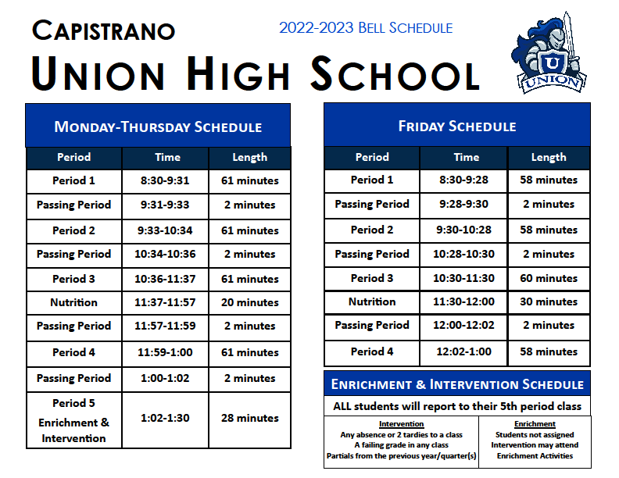

I have reviewed the contract and agree to comply with the Union High School attendance policy.
I understand that my attendance will be reviewed each quarter to determine my continued enrollment at Union.

______ ____________________________ _______________________ _______________________
Date Student Name (print) Student Signature Parent/Guardian Signature

Capistrano Unified School District
Union High School
San Juan Capistrano, California
2022-2023

PARENT - SCHOOL COMPACT
Capistrano Unified School District (CUSD) and Union High School strive to develop student potential in academic and social skills. We know learning can take place only when there is a combination of effort, interest, and motivation. As we are all committed to your students’ progress in school, we are going to do our best to promote his/her achievement and growth. To establish and foster the academic improvement and to support the success of our students, this Parent-School Compact serves as a planned partnership of parents/guardians, students, families, and the school.

Parent/Guardian and Family Responsibilities
We understand that participation in our student’s education will help in their achievement and attitude. Therefore, we will:

- Support CUSD’s and Union’s attendance, schoolwork, and discipline policies.
- Make sure that our student attends school regularly, is on time, prepared to learn with all schoolwork completed, and well-rested and healthy.
- Ensure our student has a working Chromebook with them at school daily.
- Provide a quiet place and time for our student to do and complete schoolwork.
- Know what skills our student is learning in class each day, providing encouragement and support.
- Review all school communications and return school requested responses promptly.
- Attend parent-teacher conferences and communicate via Canvas and/or phone conversation about how our student is doing.

Student’s Responsibilities
I realize that my education is important to me. I know that I am the one responsible for my success. Therefore, I will:

- Come to school regularly, on time, ready to learn with all schoolwork completed.
- Bring a charged Chromebook with me to school daily.
- Be responsible for my behavior and attitude.
- Pay attention to my teachers, family, support staff, and ask questions when I need help.
- Be willing to change my behavior to become what the school wants me to become and not try to change the school to suit my behavior.
- Trust that my teachers and school staff want me to be successful and comply with their directives, procedures, and policies.

School Responsibilities:
We understand the importance of the school experience for every student and our role as educators and models. Therefore, we will:

- Provide quality teaching and leadership to our students and their families in a safe, positive, and healthy learning environment.
- Teach grade level skills and concepts to our students, ensuring that we cover the State and CUSD content and performance standards.
- Utilize Canvas to post all assignments, update grades, and communicate with families.
- Communicate frequently with families about their student’s progress and share with them ways to help at home.
- Recognize that students are accountable for every assignment.
- Strive to address the individual needs of your student.
- Correct and return school work in a timely manner.
- Participate in meaningful professional development.

___________________________________________ ___________________________________________ _____________
Parent Name (print) Parent Signature Date

___________________________________________ ___________________________________________ _____________
Student Name (print) Student Signature Date

___________________________________________ _____________
Principal Signature Date
UNION HIGH SCHOOL
Cell Phone Policy
We respect your need to have a cell phone, and we ask that you respect our rules regarding them.
The following school wide policy will be enforced by each staff member at Union High School.

CELL PHONES ARE TO BE TURNED OFF AND
NOT VISIBLE OR ACCESSED DURING CLASS TIME

1st Infraction: Warning

2nd Infraction: Your cell phone will be confiscated and returned to you at the end of class. Your parent will be notified and warned regarding consequences of future violations.

3rd Infraction: Your cell phone will be confiscated for the day. Your phone will be given back to you at the end of the day.

4th Infraction: Your cell phone will be confiscated and given to the principal. The phone will need to be picked up by a parent.

Additional Infractions: Will be viewed as defiance of authority and school environment disruptions, and the student may be suspended from school and earn step advancements on the Behavior Contract.

I acknowledge that this is the Union High School Cell Phone Policy and that all students will be expected to comply in order to maintain a positive and productive learning environment.

Student Cell Phone Number : ( ) - .

___________________________________ ___________________________________________
Student Name (print) Student Signature
__________________________________ ___________________________________________
Parent Name (print) Parent Signature

_______________________________ ____________________________ __________
STUDENT LAST NAME STUDENT FIRST NAME GRADE

Capistrano Union High School
2022-2023 ENRICHMENT OFF-CAMPUS PARENT PERMISSION SLIP

Each quarter, students will be enrolled in a 5th period Homeroom class. Daily attendance will be taken during Homeroom and absences may affect the SARB process and/or progressive discipline. The purpose of 5th period Homeroom is to provide an additional opportunity for Union High School students to gain access to Enrichment and Intervention from our highly qualified staff.

A student will be assigned INTERVENTION (see criteria below) and report to their homeroom on Monday-Thursday. If a student has not been assigned an INTERVENTION, they will be provided ENRICHMENT.

ENRICHMENT time provides students the opportunity to participate in additional activities, engage with support on-campus systems, or work with individual teachers on specific projects, etc… A student engaging in ENRICHMENT (rather than INTERVENTION) will go to their homeroom on Monday-Thursday for check-in, and then report to their ENRICHMENT session.

A student that has earned the opportunity to attend an ENRICHMENT session may opt out to participate in an off-campus ENRICHMENT activity (attending work, outside athletic/extra-curricular engagements, family responsibilities, etc…)

Students without a signed OFF-CONTRACT on file, will be expected to remain on the
Union High School campus for the duration of Enrichment/Intervention;
any absences may affect the SARB process and/or progressive discipline.

Students, who are 18 or older, may sign for themselves. Please check one:

_____ When given the opportunity for ENRICHMENT, I give the above-named student permission to leave campus ONLY when they have met the requirements listed below.

_____ I do not wish for my student to leave campus, and would rather they remain in an ENNRICHMENT session.

_______________________________________ _______________________________________
PRINT PARENT/GUARDIAN NAME PARENT/GUARDIAN SIGNATURE

_____ I am a student, who is 18 or older, and I would like to leave campus when given the opportunity for ENRICHMENT and if I have met the requirements listed below.
INTERVENTION
Students will remain in (Monday-Thursday) INTERVENTION,
held in their 5th period Homeroom, for the following reasons:
- Students have ANY absence of 2 tardies to a class.
- Students have a failing grade in any class.
- Students have partials from the previous year/quarter(s).

ENRICHMENT
Students NOT assigned INTERVENTION can attend ENRICHMENT,
held during their 5th period Homeroom, if they meet the following criteria:
- Student has clear attendance (no absences or 2+ tardies)
- Student is passing all current classes (not earning an F throughout the quarter)
- Student did not earn partial credits for previous completed courses
- The privilege of leaving campus may be revoked at any time by school administration

_______________________________________
ADULT STUDENT SIGNATURE

Capistrano Union High School
Social and Emotional Support Survey

In an effort to help support every student at Union High School,
please complete the form below if you would like our school counselor
to be familiar with your student’s mental health history.

Student Name: ______________________________________________ Date: ________

DO YOU SEE ANY DEPRESSION IN YOUR STUDENT 0 1 2 3 4 5
(Low) (Very High)

DO YOU SEE ANY ANXIETY IN YOUR STUDENT 0 1 2 3 4 5
(Low) (Very High)

DOES YOUR STUDENT HAVE ANY HISTORY OF SUICIDAL IDEATION
YES NO
IF YES, PLEASE PROVIDE APPROXIMATE/MOST RECENT DATE __________________

HAS YOUR STUDENT EVER ATTEMPTED SUICIDE
YES NO
IF YES, PLEASE PROVIDE APPROXIMATE DATE(S) __________________

HAS YOUR STUDENT BEEN HOSPITALIZED FOR MENTAL HEALTH
YES NO
IF YES, HOW MANY TIMES __________________

DOES YOUR STUDENT CURRENTLY RECEIVE OUTSIDE SUPPORT
(THERAPIST, PSYCHOLOGIST, ETC.) YES NO

***THE PURPOSE OF THIS FORM IS FOR THE COUNSELOR TO BETTER UNDERSTAND YOUR STUDENT. NO PART OF THIS FORM WILL BE PUT IN YOUR STUDEN’T RECORD.

